Rent Control - Con

DEAR NEW YORKERS: Here's Why Your Rent Is So Ridiculously High
Josh Barro
Jul. 9, 2013, 6:59 PM
Average asking rents in New York City have climbed to $3,017, according to REIS research. Everyone is freaking out about it.
As far as we can tell, most New Yorkers have spent today complaining about high rents on Facebook instead of actually doing the high-paying jobs that allow them to pay so much rent.
But one thing we haven't seen in all those conversations is a discussion of why the rent is so damn high. Here are eight key reasons we have to pay so much to live in New York City.
1. There's only so much space. Last month, I spoke with Trulia's Chief Economist Jed Kolko about why San Francisco home prices are so high and he said, in reference to the city's geography, "God wanted San Francisco to be expensive."
That applies in New York, too: There are only so many square miles of land in the city, and especially in Manhattan. When lots of people want to live in a limited space, they bid up land prices, and that flows through to rents.
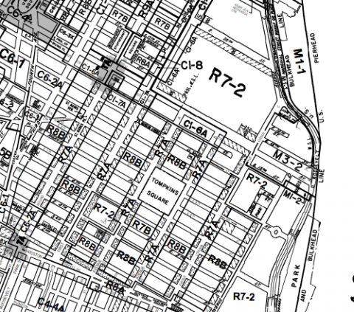
New York City Planning Commission
2. Zoning rules inhibit supply. Of course, you can get more apartments on a given amount of land by building taller buildings closer together. And compared to most cities, New York is very dense. But it could be even denser.
Take a look at this zoning map of the East Village, a popular neighborhood in Manhattan. Most of the neighborhood consists of R7A and R8B zones. These allow for a Floor-Area Ratio (FAR) of 4.0: four square feet of building area for every square foot of lot area. And accordingly, most of the housing stock in the neighborhood is closely-packed buildings of four or five stories.
If the neighborhood were instead mapped for R10 zoning, like parts of the Upper East Side, building FARs could go up to 10.0. That would allow for 2.5 times as much building space on the same amount of land. A larger supply of apartments in the East Village would mean lower rents, especially if zoning were relaxed all over the city.
Incidentally, contra Hamilton Nolan, this is a reason non-rich New Yorkers should cheer the construction of "superluxury condos." Wealthy people are going to buy in New York one way or another. When we limit their ability to build shiny new towers in Manhattan, they come over to Brooklyn and bid up the prices of brownstones that used to be almost affordable.
3. Rent control raises your rent if you're not rent controlled. While the average rent for available apartments in New York City is now over $3,000, the U.S. Census Bureau says renters in New York City were only paying a median of $1,125 in 2011. What gives?
The answer is, there are lots of cheap apartments in New York. You just can't get one of them, because they're rent controlled, and tenants with great rent controlled deals cling to their apartments until they die.
The Cato Institute produced some great charts on this back in 1997, but the same dynamics still hold in the market today. In cities without rent control, rents for available apartments form a normal distribution around the Census median rent. Here's a chart of Philadelphia rents in 1997:
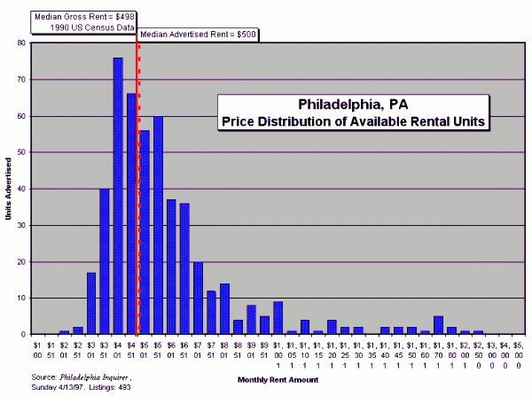
Cato Institute
But in cities with rent control, most of the available housing stock exceeds the median rent. Here's the New York chart from 1997:
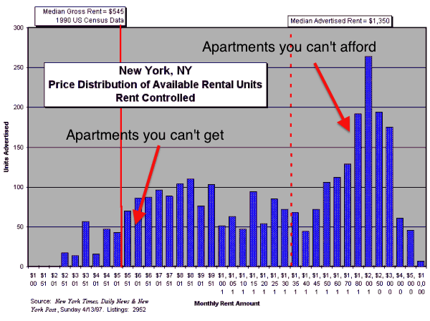
Cato Institute
Then as now, average advertised rents were about three times higher than average rents as measured by the Census Bureau. And when you look at data from the Furman Center at New York University, it's not hard to see why.
In Manhattan below 96th Street, 35% of rent regulated apartments are occupied by a tenant who has lived there for more than 20 years. Less than 3% of market-rate tenants have been around that long.
Many of those rent regulated tenants would have moved if they had to pay market rent, whether within the city or to Florida; when they hold onto their great deals, they reduce supply available to new renters, and that drives up prices for everybody else.
Rent control is not the sole driver of the gap between the REIS and Census figures. The Furman Center found a median market-rate rent around $1,550 in New York in 2011, compared to $1,160 for rent regulated apartments. But very longstanding tenants with low regulated rents are one key driver of the gap between average rents and average available rents.
4. Property taxes are very high. I wrote about this last month. New York has the second highest property tax rates on rental apartment buildings among large cities in the country; only Detroit's are higher, and that's because property there is barely worth anything. Some portion of this added tax burden gets shifted to tenants as higher rents.
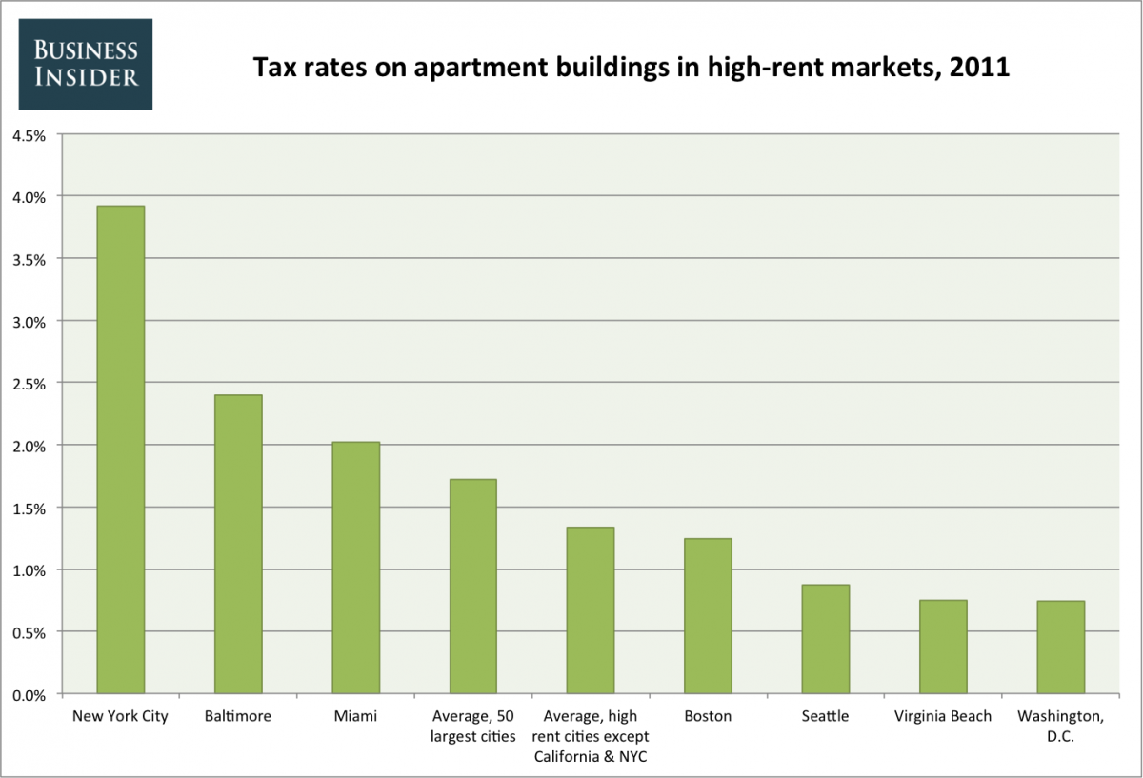
Business Insider, data from Lincoln Institute of Land Policy
5. High construction costs. In 2003, Economist Ed Glaeser reported data from the R.S. Means company showing that residential construction is 19% more expensive in Manhattan than Chicago. Higher construction costs mean higher rents.
There are lots of reasons for high construction costs in New York. Wages here are high for all kinds of workers, including construction workers. Many New York construction sites don't have spacious lots where you can store materials.
But regulation is also a likely culprit. For example, New York has an unusually stringent law requiring frequent and costly inspections of building facades, which is why you see so much more scaffolding in Manhattan than other cities.
And there are no non-union crane operators in New York City, meaning any construction project tall enough to require a crane must be built with union labor. That adds costs; union work rules require overstaffing, according to the Real Estate Board of New York, and some crane operators in the city make over $500,000 a year including overtime and benefits.
6. Affordable-housing set asides. Much new multifamily construction in New York City is built under programs where developers get a tax abatement in exchange for setting aside a fraction of the building for affordable housing.
That's great for people who win affordable housing lotteries and get below-market rate rents. But the set-asides also reduce the returns to developers, which reduces the amount of housing stock that gets built, which drives up market rents for everybody else.
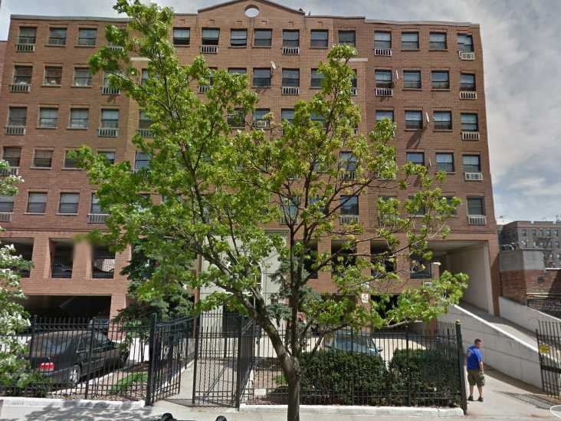
Google Street View
This apartment building in Sunnyside, Queens has an above-ground parking garage, mandated by zoning, despite being four minutes from the subway.
7. Minimum parking requirements. In general, buildings below 96th Street in Manhattan don't have to have parking. But in upper Manhattan and the outer boroughs, developers are forced to build parking (often, more than is demanded by tenants) if they want to build apartments.
That drives up costs and discourages construction. My neighborhood of Sunnyside, Queens is a testament to this.
I live in a six-story elevator building four minutes' walk to the subway. My building was built in 1937 and has no parking. If you wanted to build it today, you would have to put a parking garage under it. As a result, even though the neighborhood is desirable, new construction is limited.
The building in the picture is next door to mine. It was built after New York City's 1961 zoning reform and so it has above-ground parking. It's one of the few post-1950 apartment buildings in my neighborhood. It's also hideously ugly.
8. Tenant-friendly laws. It's really hard to evict a tenant in New York. That's great if you're a deadbeat. It's also the reason that landlords almost uniformly require a full month's rent in deposit—New York's legal maximum for most apartments. I didn't even know this was abnormal until I moved away from New York for a time and discovered that tenants with good credit could sometimes post little or no deposit in other markets.
The hassle of being a landlord in a tenant-friendly jurisdiction also discourages rental construction at the margin (again driving up rents) and encourages landlords to be extra picky about tenants' credit. It's just another reason it's so difficult and expensive to rent here.
Source: Barro, Josh. “Dear New Yorkers: Here’s Why Your Rent is so Ridiculously High,” Business Insider. 9 July 2013. http://www.businessinsider.com/the-8-reasons-why-new-york-rents-are-so-ridiculously-high-2013-7. Accessed 21 July 2014.

The Perverse Effects of Rent Regulation

By ADAM DAVIDSON
For Alejandro Suarez, the change in the East Village is easily visible on the shelves of the bodega where he has worked for seven years. On the corner of East 12th Street and Avenue A, the store used to be at the borderline between the richer people to the West and the poorer people to the East. When Suarez started, he sold lots of beans and rice to the Hispanic people who lived on the block. But Goya products are now crammed on a tiny shelf way in the back, while up front, there’s a huge and growing selection of organic produce, vegetarian sandwiches and high-end energy bars.
The East Village and the broader Lower East Side make up one of the most economically integrated parts of the city. It is one of the last places where the fairly rich and the very poor live on the same blocks and shop in the same bodegas. But the area is steadily becoming more like most of Manhattan: dominated by those with high incomes paying seemingly absurd rents, while the poor either leave or stay in government housing on the periphery. While older affordable housing is reaching the end of its life cycle, new affordable housing’s major source of public funding — Congress — is planning comprehensive tax-and-spending reform. This could pose an existential threat to New York’s regulatory efforts to keep Manhattan affordable for the poor.
So what would happen if Manhattan were completely free of rent regulations and other forms of housing subsidies? According to several housing analysts, it would quickly become an island occupied solely by middle class and rich people. Christopher Mayer, a housing economist at Columbia Business School, imagines tens of thousands of professionals, currently scared away by insane rents, moving in from Brooklyn, Queens and Hoboken — even Philadelphia and Chicago. “Poor people would be priced out of Manhattan,” he says. “Period.” But an East Village where nobody makes less than $90,000 a year might actually damage the city’s long-term prospects.
Manhattan has had an outsize impact on the world’s culture and economy in large part because of its economic diversity. Home to broke writers and wealthy publishers, starving painters and well-heeled collectors, unproven fashion newcomers and the established houses, and countless other symbiotic pairings, Manhattan has been a place where unlikely ideas can build an audience and, sometimes, dominate the mainstream. For 200 years, the East Village has served as an initial toehold into this chaotic mess. But rent regulation may not be helping keep it diverse.
Rent control first appeared in the 1940s, when soldiers returned to the city seeking apartments for their new families, causing rents to rise drastically. Since then, countless housing programs have been created at local, state and federal levels, but the biggest housing intervention in New York today is rent stabilization: a slightly more flexible version of rent control, in which a city board of experts annually determines how much more landlords can charge their tenants.
The problem, though, is that these programs actually make the city much less affordable for those unlucky enough not to live in a rent-regulated apartment, Mayer says. The absurdity of New York City’s housing market has become a standard part of many Econ 101 courses, because it is such a clear example of public policy that achieves the near opposite of its goals. There are, effectively, two rental markets in Manhattan. Roughly half the apartments are under rent regulation, public housing or some other government program. That leaves everyone else to compete for the half with rents determined by the market. Mayer points out that most housing programs tie government support to an apartment unit, not a person. “That is completely nuts,” he says. It creates enormous incentive for people to stay in apartments that no longer fit their needs, because they have had kids or their kids have left or their job has moved farther away. This inertia is a key factor in New York’s housing shortage. One East Village real estate agent told me that only 20 to 30 units are available in the entire area any given month.
This might be acceptable if all the rent-controlled and rent-stabilized units were inhabited by the poor people the programs were designed to help and if most poor people lived in rent-regulated units. But according to data from N.Y.U.’s Furman Center for Real Estate and Urban Policy, a majority of people in rent-regulated Manhattan apartments make far above the poverty level.
Interestingly, advocates for continued rent regulation and those who oppose it largely agree on what would happen if the programs were eliminated. It would be win-win-lose: great for landlords and the middle class and awful for people who benefit today. Mayer walked me through a likely result. Many of the people receiving some sort of government subsidy would have to leave their apartments, probably for the outer boroughs. The landlords of those units would invest in upgrades and charge higher rents. At the same time, the subset of apartments that had been market rate would see their rents fall, because there would be, suddenly, twice as many apartments in the market.
For Mayer, as for many economists, this is proof that rent regulation is an incredibly expensive program, preventing billions of dollars of development. It also creates an odd lotterylike system in which those who are lucky enough to have a rent-regulated apartment can live in the best parts of the city for next to nothing and everyone else is shunted aside. Eliminating rent regulation would be such a huge windfall for landlords, Mayer says, that he could imagine a sort of grand bargain. The programs go away, but landlords have to pay higher property taxes. The extra city revenue could go to a fund to help poor people afford market-rate apartments. In theory, this could be designed to make the shift win-win-win. The city could stay socioeconomically diverse without any six-bedroom apartments renting for $225.
Vicki Been, the director of N.Y.U.’s Furman Center, says most rent-regulation advocates acknowledge some of Mayer’s criticisms but want to keep the programs anyway. “We can’t just say, ‘Let’s get rid of rent regulations and replace them with the optimal system,’ ” she says. “The political forces that would get rid of rent regulation would not be the forces looking for optimal legislation.” It would be landlords and developers. In the political battles that define New York’s real estate market, she says, the poor rarely come out ahead. And rent regulation — however inefficiently — does help many poor people.
Rent regulation is very likely to go away, eventually, even without any explicit effort to kill it. Some 231,000 units have been deregulated over the last 30 years. Every year, thousands more leave the program or are torn down, replaced by new condo buildings serving the wealthy. The number of market-rate units has been going up more quickly lately, and the pace will, most likely, only increase. Barring some unlikely shift in the economy or policy, Manhattan will have fewer and fewer poor people each year and almost none whatsoever in a few decades. What happens if all the rich people are on one island and the poor but creative are somewhere else? It might just destroy the strange admixture that makes Manhattan so appealing in the first place.
Source: Davidson, Adam. “The Perverse Effects of Rent Regulation,” The New York Times Magazine. 23 July 2013. http://www.nytimes.com/2013/07/28/magazine/the-perverse-effects-of-rent-regulation.html?pagewanted=all&_r=1&. Accessed 21 July 2014.

